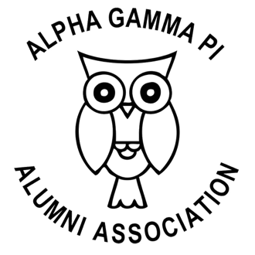
www.alphagammapialumni.org

Find workshop resources for everything from leadership development, scholarships, and Hallmark Awards. We work to ensure that all of our resources are accessible to those with disabilities.

President
Jennifer Palmer-Lee
president@alphagammapialumni.org

Vice President
Jeannie Schaefer
vicepresident@alphagammapialumni.org

Treasurer
Katherine Lyon
treasurer@alphagammapialumni.org

Critical Reviews of Hallmark Entries
First Come, First Served
Send any Hallmark essays in *.rtf format to our single point of contact:
candaceeldridgeutd@yahoo.com

